**Experiment-3**

**Name:** Dhrish

**Unique ID:** E0320008

**Problem Statement:**

Identify the open, close ports and protocols using tools.

**Tools used:**

**Nmap:**

Nmap is a free and open source network discovery and security auditing utility that widely used in linux Nmap works by sending data packets on a specific targeted and by interpreting the incoming packets to determine what ports are open or closed whether firewalls or filters are setup and enable and finally whatoperating system is running.

**Procedure:**

1. Installation Of Nmap tool:

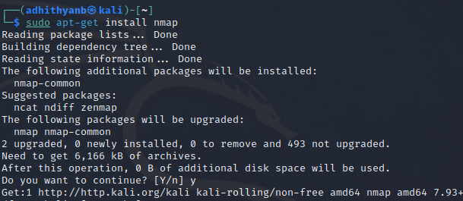

1. To show all related nmap commands:

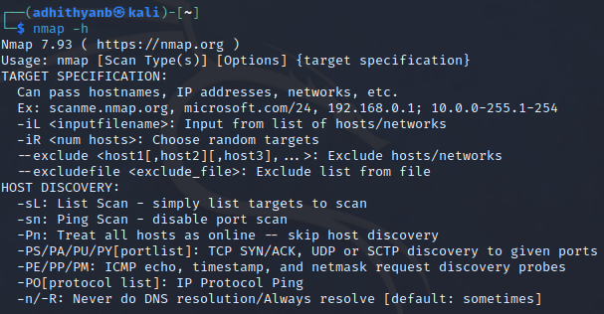

1. To scan Nmap ports:

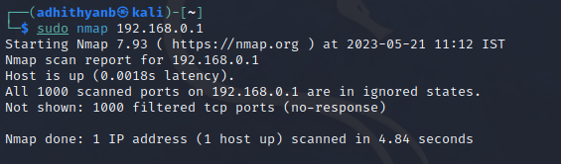

1. To scan a range of IP address(.1-.10)

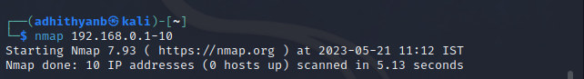

1. To scan fast in most common ports:

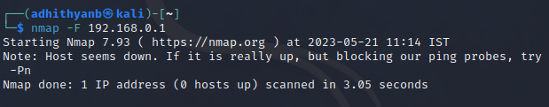

1. To scan all ports(1-65535):

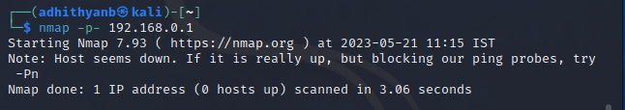

1. To scan using TCP Connect:

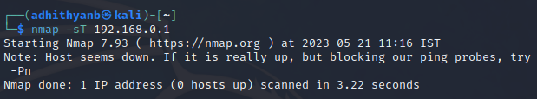

1. To perform default SYN Scan:

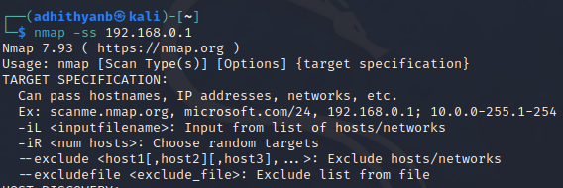

1. To run fast scan on the target system:

